Add Molecular Diffusion and Dispersion Capability to GPRS

Yaqing Fan

Last modified on: December 13, 2006

1. Introduction

The combined effect of molecular diffusion and mechanical dispersion is called physical dispersion. Modeling of these effects introduces an additional term in the mass balance equation. Molecular diffusion is caused by the random motion of the molecules. Mechanical dispersion is caused by velocity fluctuations. In this chapter, the diffusion and dispersion model implementation in GPRS is described. For a miscible displacement case, the smoothing effects of diffusion and dispersion are shown.

2. Mass Balance Equation

The mass conservation equation in the GPRS compositional simulator without dispersion is:
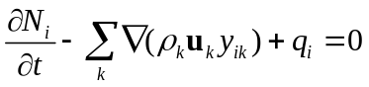, (1)
where 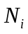is the mass of component i in an arbitrary representative elementary volume (REV), 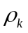is the density of phase k , 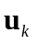is the Darcy velocity of phase k, 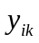 is the mole fraction of component i in phase k, and 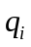is the production rate of component i from this REV.

In Equation (1), the first term is the accumulation term, the second term is the convective flux, and the third term is the sink/source. For most cases, Equation (1) is generally adequate for predicting the performance of reservoirs. However, dispersive effects may be important for miscible displacements. The mass balance equation with dispersion is as follows [1]:
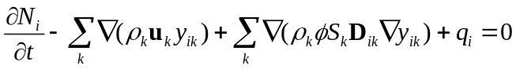, (2)
where denotes the porosity, 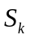 denotes the saturation of phase k, and  is the dispersivity tensor for component in phase k. The new term including the dispersion tensor is called the dispersive flux term. Unlike the convective flux which is driven by a potential gradient, the dispersive flux is driven by the gradient of mole fraction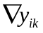.

The dispersion tensor consists of molecular diffusion coefficients, which appear on the diagonal, and mechanical dispersion coefficients, which contribute both on and off the diagonal. The elements of the dispersion tensor are given by [1]:

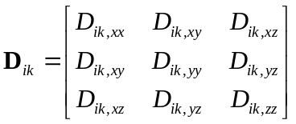, (3)
where the elements of 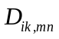 are represented by:
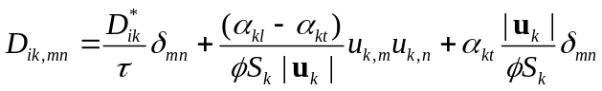, (4)
where 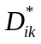 is the diffusion coefficient, is the permeable media tortuosity factor, 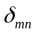 (unit tensor) is 1 when m=n and zero otherwise, 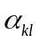 is the longitudinal dispersivity of phase k, and 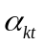 is the transverse dispersivity of phase k. We reiterate that i and k correspond to component and phase (respectively), while m and n designate vector or tensor components.

It is convenient to split the dispersion tensor into two parts:
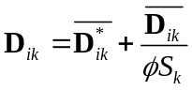, (5)
where 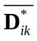 is a diagonal tensor containing only the diffusion coefficients:
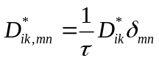, (6)
and 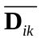 is the mechanical dispersion tensor:
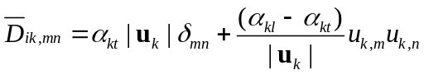. (7)

Substituting Equation (5) to Equation (2), we have:
. (8)

3. GPRS Implementation

Implementation of diffusion and dispersion is very similar to the convective flux part of the flow equation. So far, the implementation is limited to compositional simulation with two-point formulation. Also, the coordinates have to be orthogonal. The C++ classes for both black-oil models and multi-point models are developed without implementation. The class hierarchy of the diffusion and dispersion is shown in Figure 1. Note that the arrows indicate friend classes.

The implementation in GPRS is along the lines of Equation (8); i.e., molecular diffusion and mechanical dispersion terms are treated separately. For diffusion, the tensor (for all i and k) is input by the user. The keyword is DIFFUSION_COEFF. The diffusion coefficient data have to be input in the FLUID_DATA section of the input file. For a system consisting of m phases and n components, the user must input a matrix that includes all the diffusion coefficients of n components in each phase. For example, the input part a two-phase system with two components is shown in table 1.

mthFlowEqnModel
mthBOFlowEqnModel
mthCompFlowEqnModel
mthFlowEqnDiffImp
mthFlowEqnDiff2PImp
mthFlowEqnDiffMPImp
mthBOFlowEqnDiff2PImp
mthCompFlowEqnDiff2PImp
mthBOFlowEqnDiffMPImp
mthCompFlowEqnDiffMPImp

Figure 1. Diffusion and Dispersion Classes Hierarchy

DIFFUSION_COEFF ##################################
# --- component coefficient in phases (nPhases by nComps) ---
#comp: C1 C7+1
100 100 #gas
100 100 #oil
END

Table 1. Sample input data for diffusion coefficients

The molecular diffusion term is treated fully implicitly in GPRS. To explain the derivatives regarding to primary variables, let’s consider a connection between block A and block B. According to Equation (8), the flux of component i in phase j from block A to block B will be:
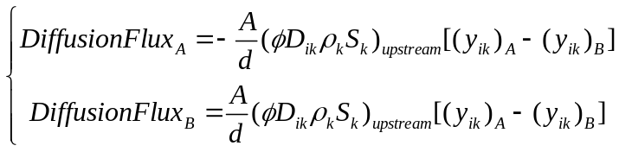, (9)
where denotes the area of the connection between these two blocks, and denotes the distance between the geometric centers of these two blocks. The positive sign means the flux is flowing in, and the negative sign means the flux is flowing out. We can see that we need the derivative of either 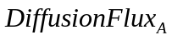 or 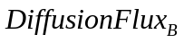with respect to pressure, saturation and mass fraction. The expressions are given below using as example.
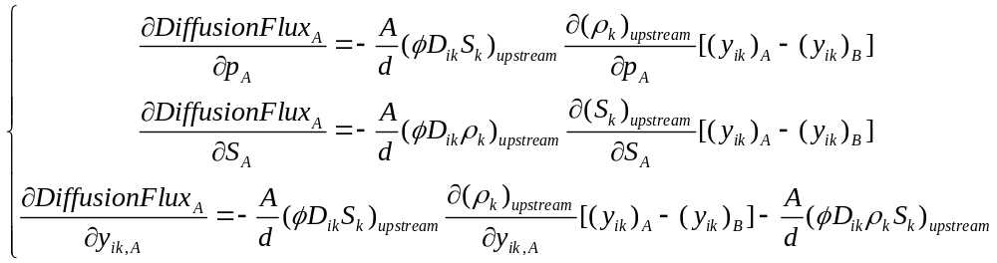(10)
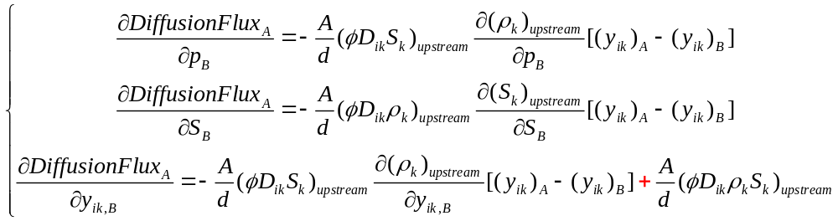 (11)

In order to calculate the dispersive flux, the velocity of each phase needs to be calculated in each block. First, we compute the velocity of each phase at the block interfaces. Then, the velocity at the cell center is calculated by averaging the velocities computed at the interfaces. Next, the mechanical dispersion tensor elements 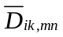 are constructed from the cell-center velocities. In the current implementation, we adopt the approach of Jessen et al. [2] in which the mechanical dispersion is treated explicitly. If the mechanical dispersion option is activated, the longitudinal and transverse dispersivity are input by the user. The format is similar to that for diffusion coefficients. But the dimension of the dispersion coefficient is 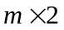(supposing there are m phases).
DISPERSIVITY ################################
# long transverse
1 0 #gas
1 0 #oil
END

4. Example Case

Numerical experiments in GPRS tell us that the diffusion and dispersion effect can be shown when the scale of the reservoir is small and when the miscibility of the phases is not negligible. In the first case, we consider a 1D problem in which the reservoir is originally saturated with 100% oil. Pure methane is injected one of the end of the one-dimensional reservoir under BHP control, and a producer under BHP control at the other end of the reservoir.

The parameters for the case are listed as follows:

Parameter | Value
Nx | 40
Ny | 1
Nz | 1
Dx (ft) | 2
Dy (ft) | 2
Dz (ft) | 2
Kx (md) | 200
Ky (md) | 200
Kz (md) | 50
Porosity | 0.30
Components | C1, C7
Injector | Block 39, injecting gas
Producer | Block 0
Well control | Injector: BHP (2200 psia);  Producer: BHP (1500 psia)
Diffusion coefficients (oil phase) | C1: 100 ft²/day; C7: 100 ft²/day;
Diffusion coefficients (gas phase) | C1: 100 ft²/day; C7: 100 ft²/day;
Longitudinal dispersivity | C1: 1 ft; C7: 1 ft;
Transverse dispersivity | C1: 0 ft; C7: 0 ft;

The case is very difficult to run in terms of numerical Newton-Raphson iteration. The maximum timestep in this case is set to 0.002 day if diffusion or dispersion is included.

The results of C₁ concentration at t = 1 day are compared for the cases without diffusion or dispersion, with diffusion only and with dispersion only. The gas saturation profiles of these three cases are also compared in one figure. We can observe that the diffusion and dispersion have a smoothing effect. Compared to the default case (in which neither diffusion nor dispersion is included), the profile of the gas saturations from block 7 to 13 are of non-zero values, while those in the default case these values are zero.

In this case, the results from the diffusion case and the dispersion case are similar to each other. It approves that the mechanism of diffusion and dispersion are alike.

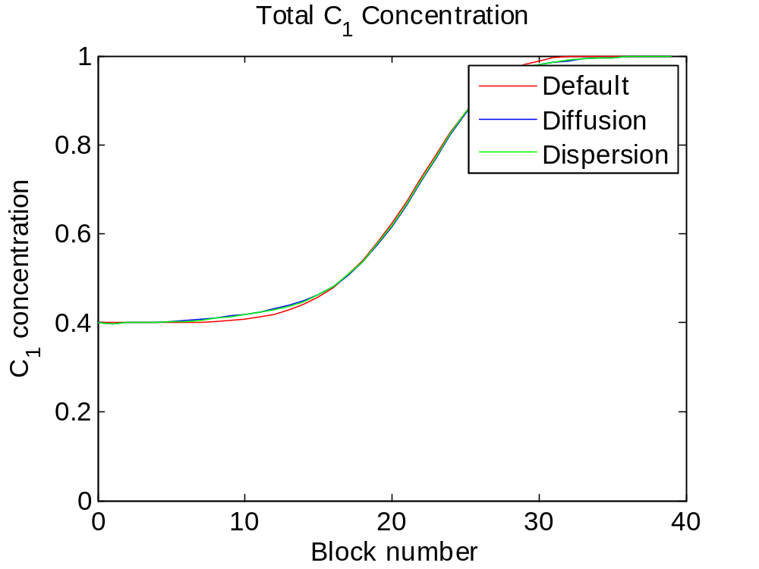

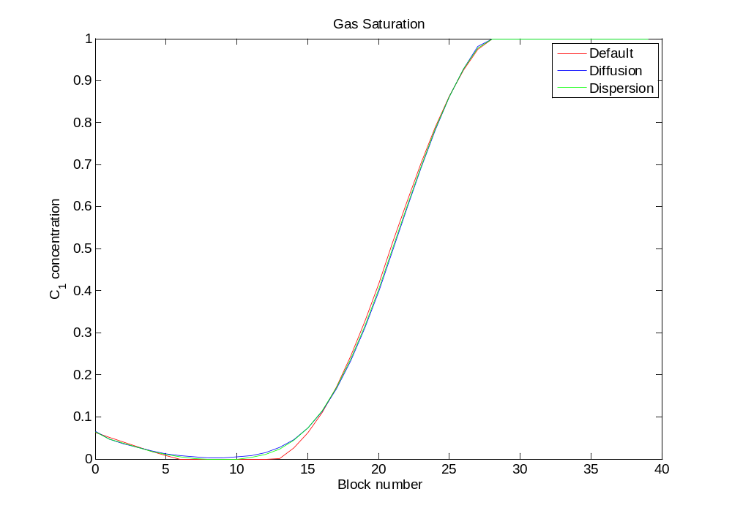

5. Conclusions and Future Work

Molecular diffusion and mechanical dispersion have been implemented in to the current version of GPRS. While these features only work for two-point compositional model, the framework is ready to expand to multipoint or black-oil model. The smoothing effects of both diffusion and dispersion are shown in a miscible displacement. Numerical experiments do not show such effects for immiscible cases. Future work may include implementation of diffusion and dispersion in black oil models. Another possible direction is to investigate diffusion and dispersion in non-orthogonal gridding systems.

References:

[1]. J. Bear. Dynamics of Fluids in Porous Media, Dover Publication, New York, 1988.
[2]. K. Jessen, M.G. Gerritsen, and B.T. Mallison. High-resolution prediction of enhanced condensate recovery processes. SPE 99619 presented at the SPE/DOE Symposium on Improved Oil Recovery held in Tulsa, Oklahoma, 22-26 April, 2006.

